**Module 5 - Deploying and Managing API’s**

**Deploying applications to CloudHub:**

Customer Account API app deploy to Cloudhub.

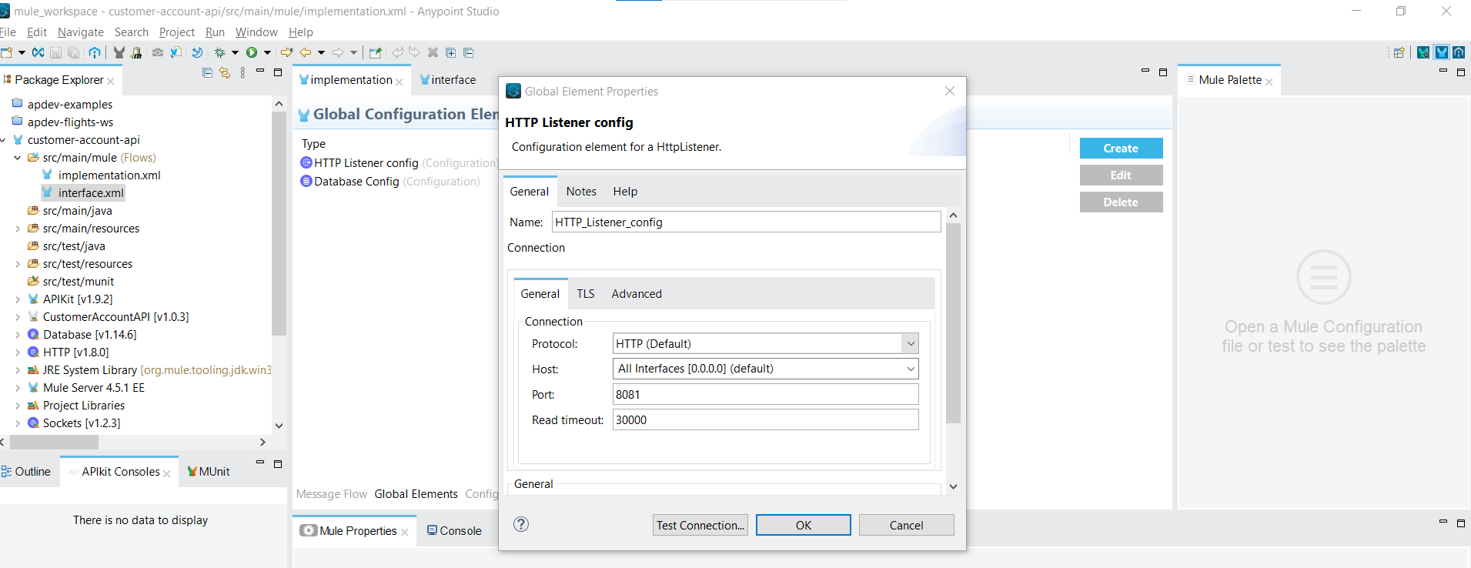

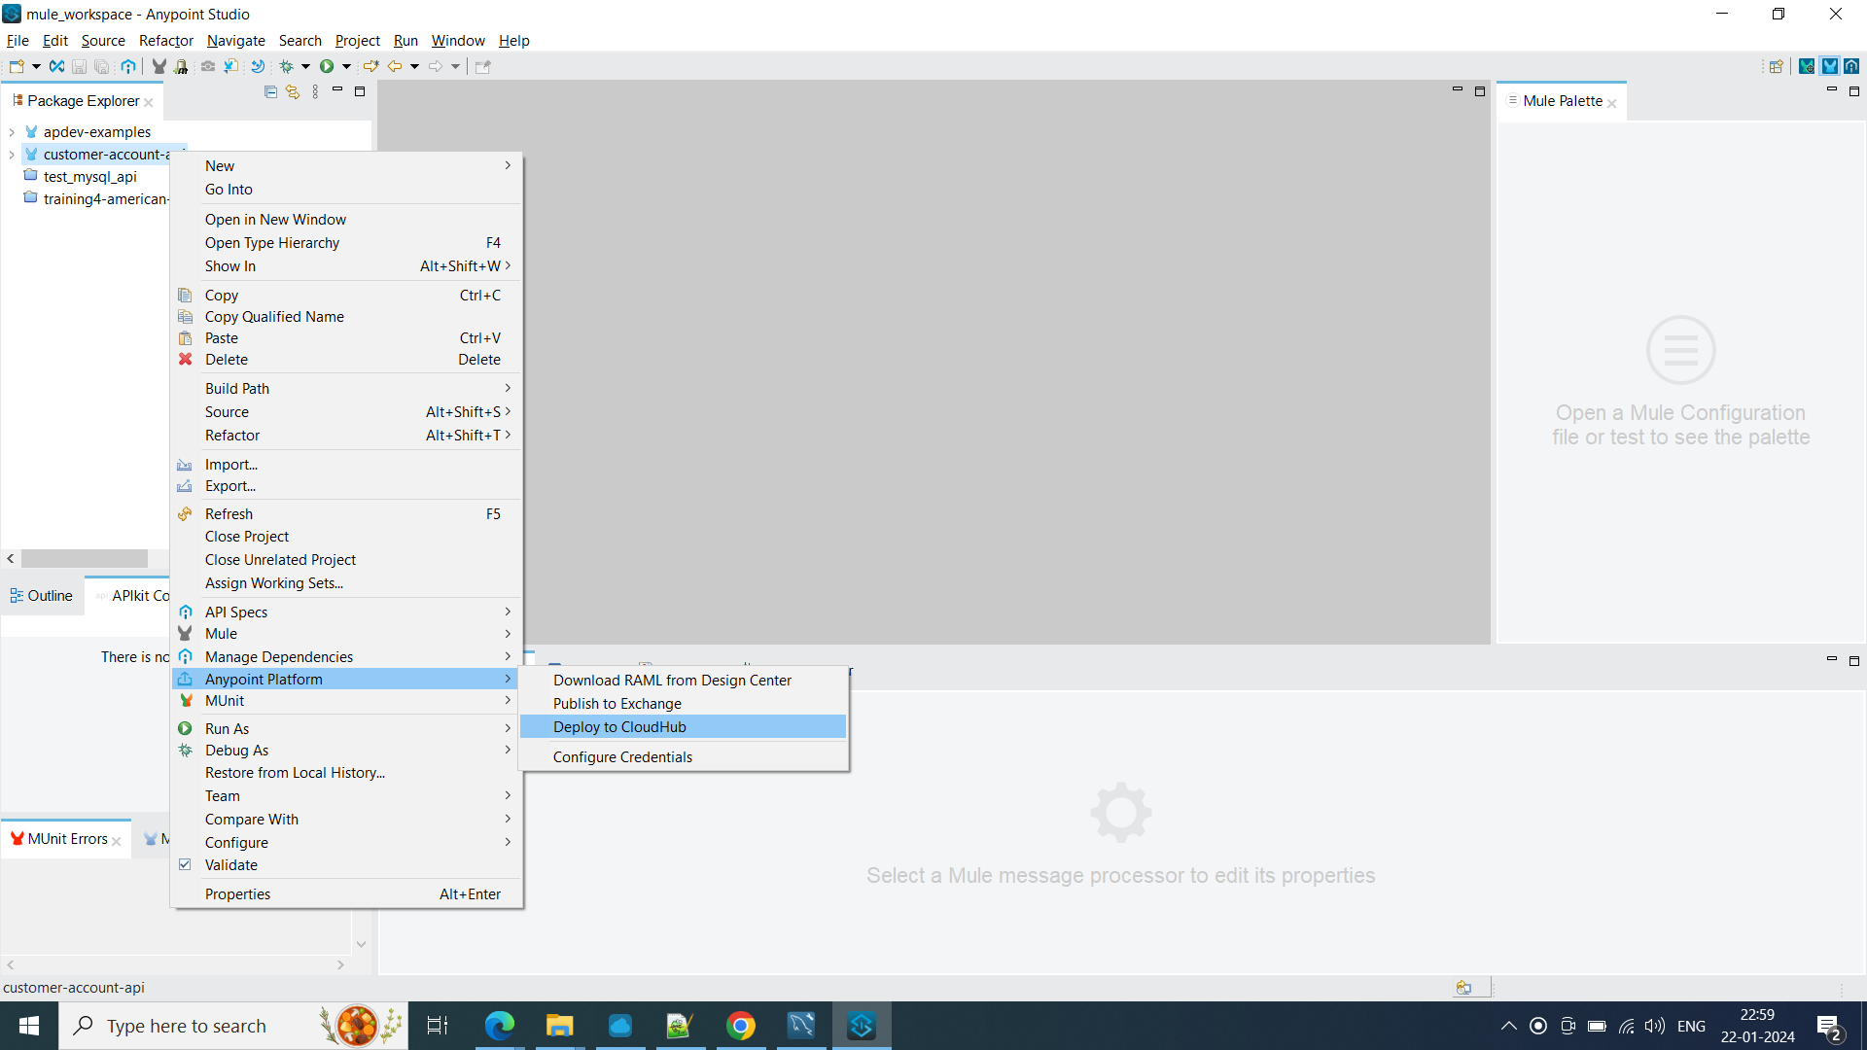

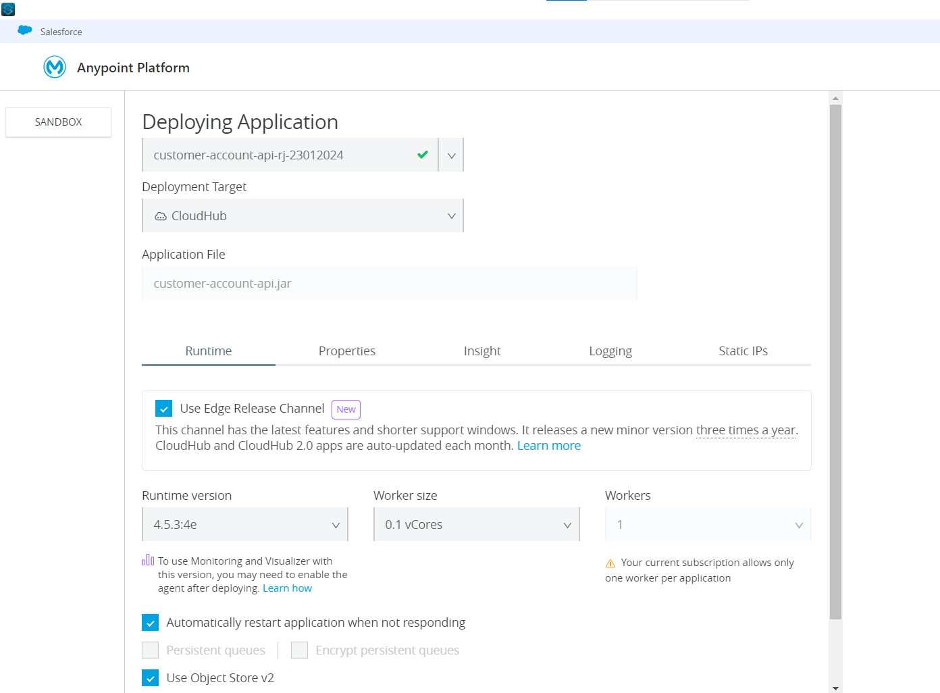

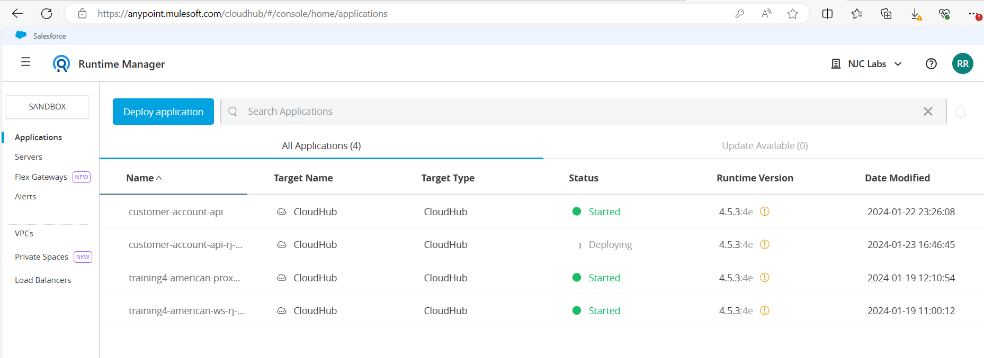

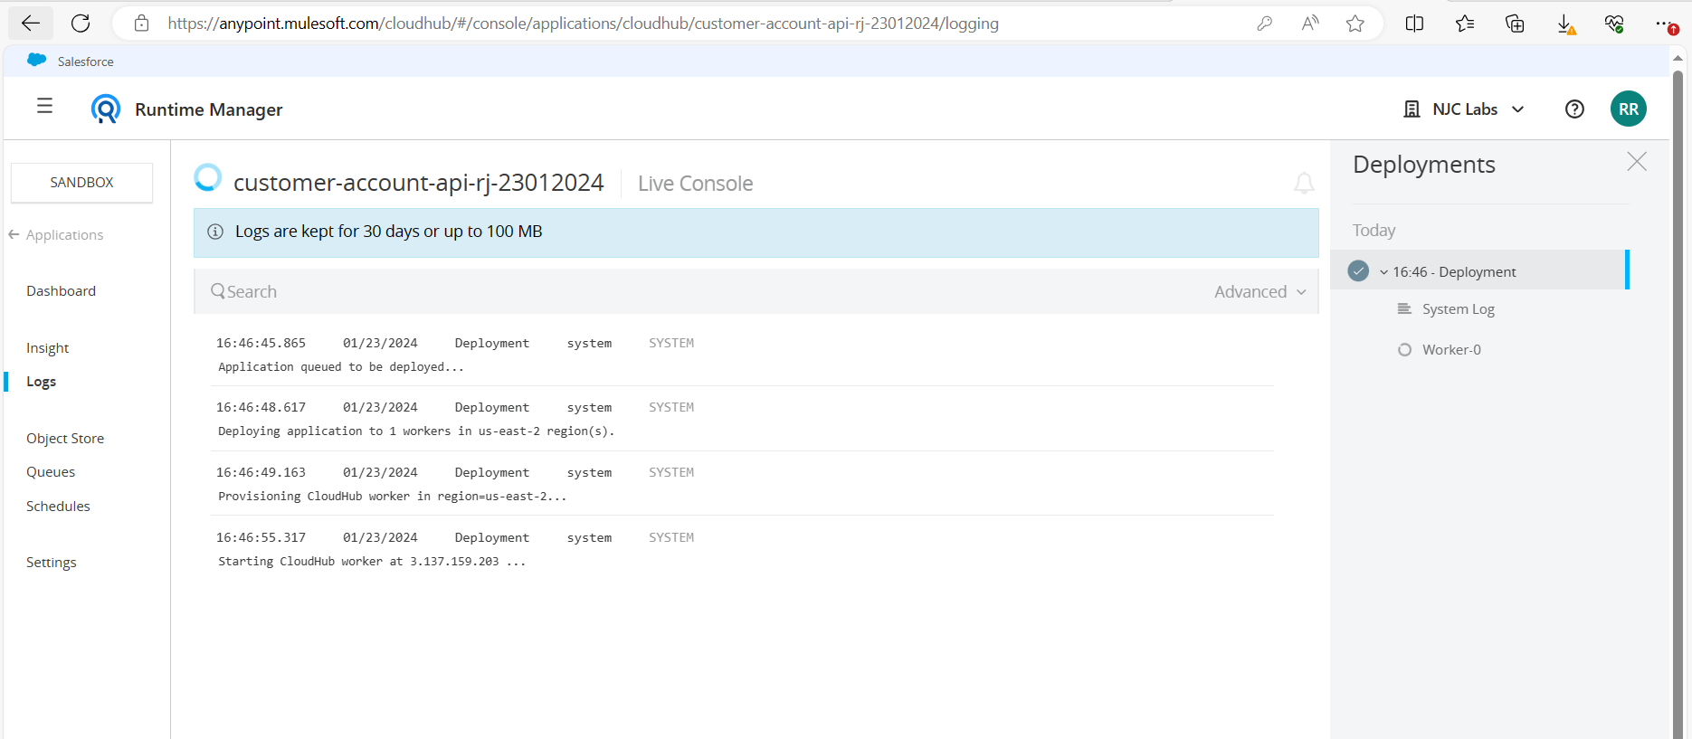

Application Started:

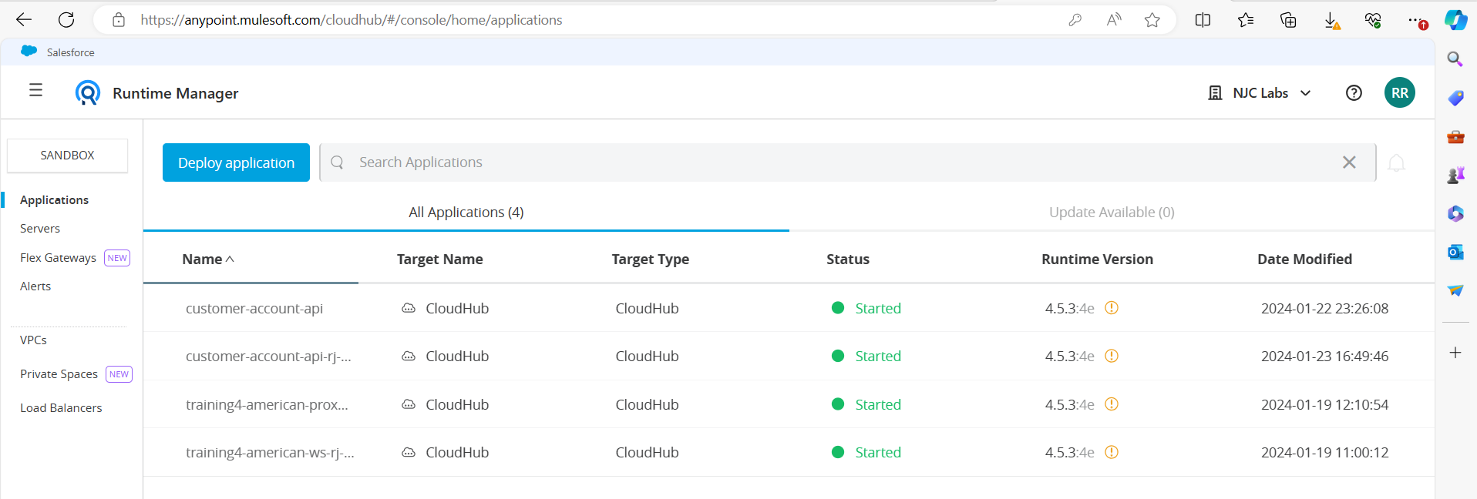

Test in ARC:

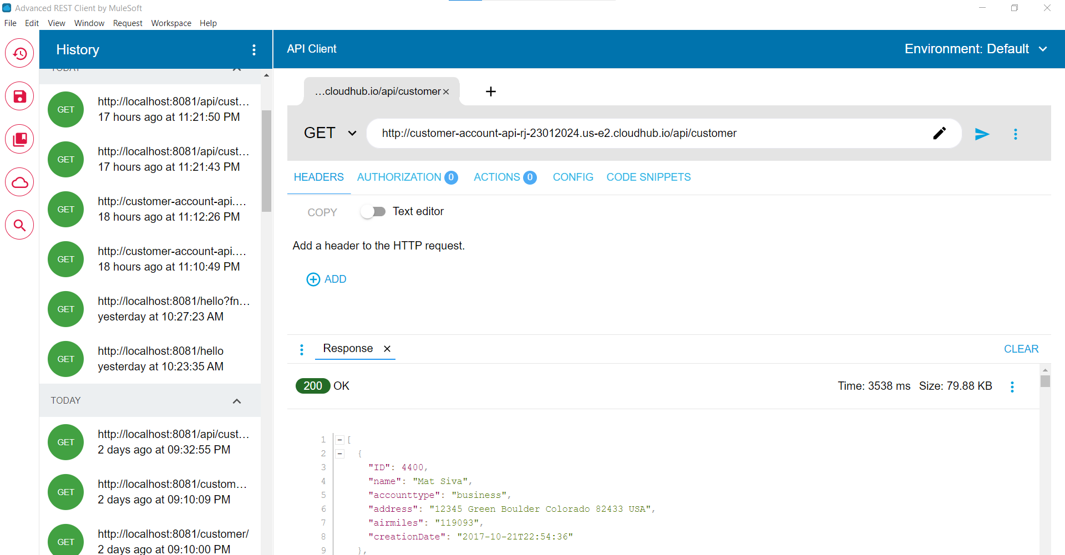

Testing with account ID:

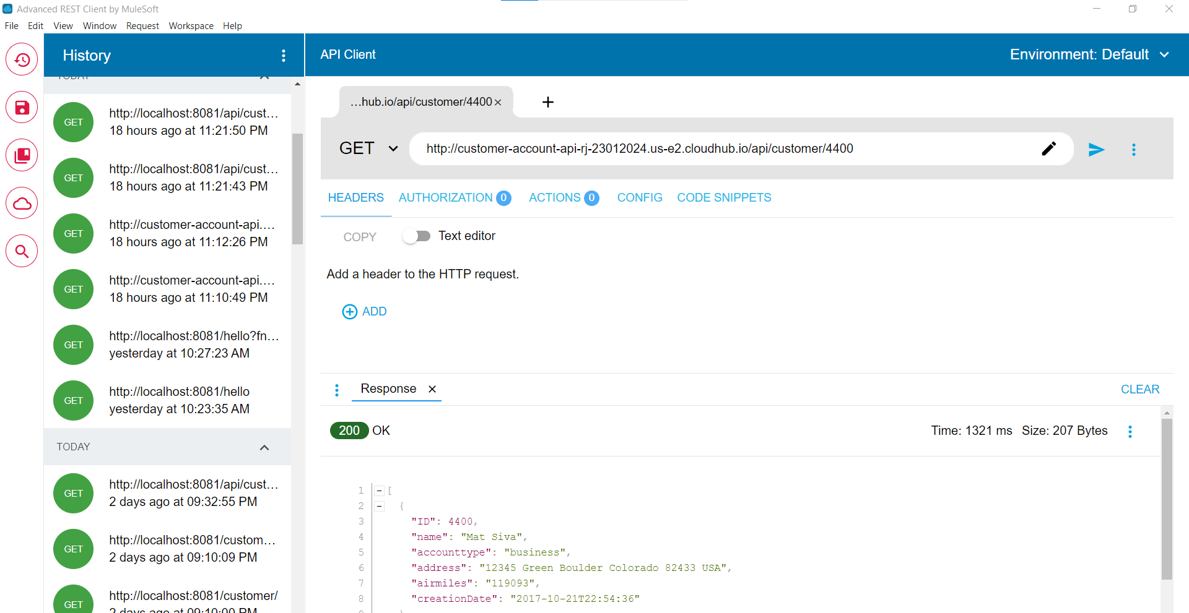

**Creating API Proxies:**

API Manager:

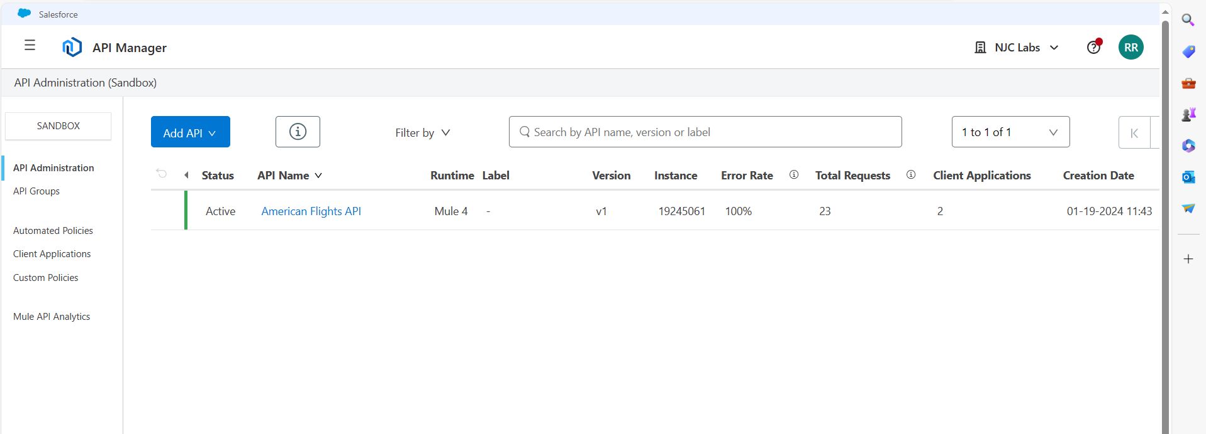

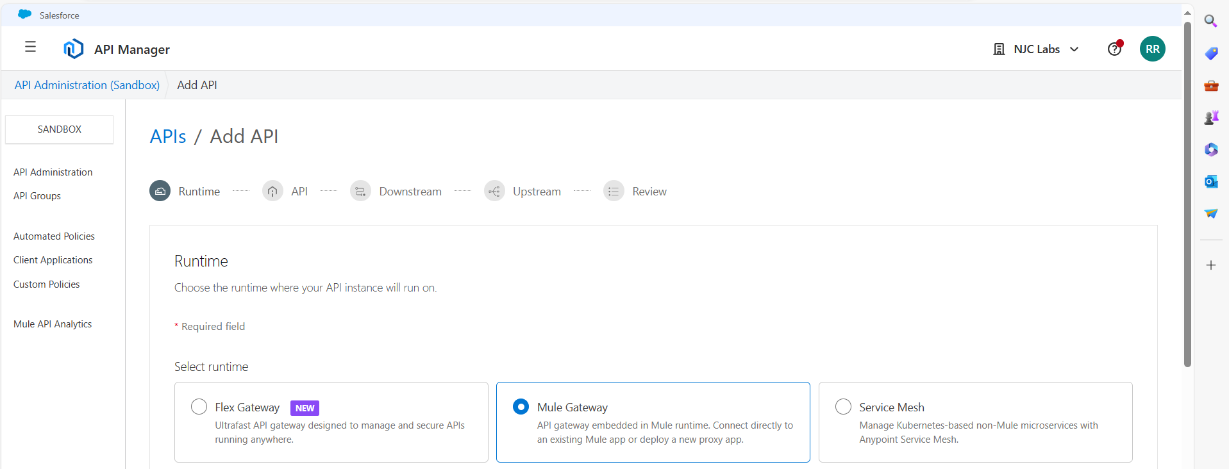

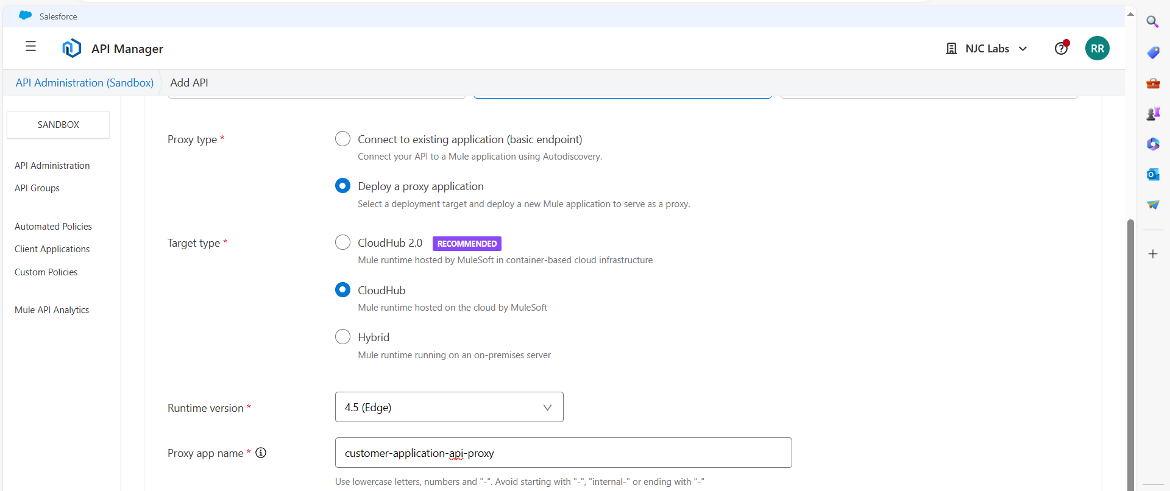

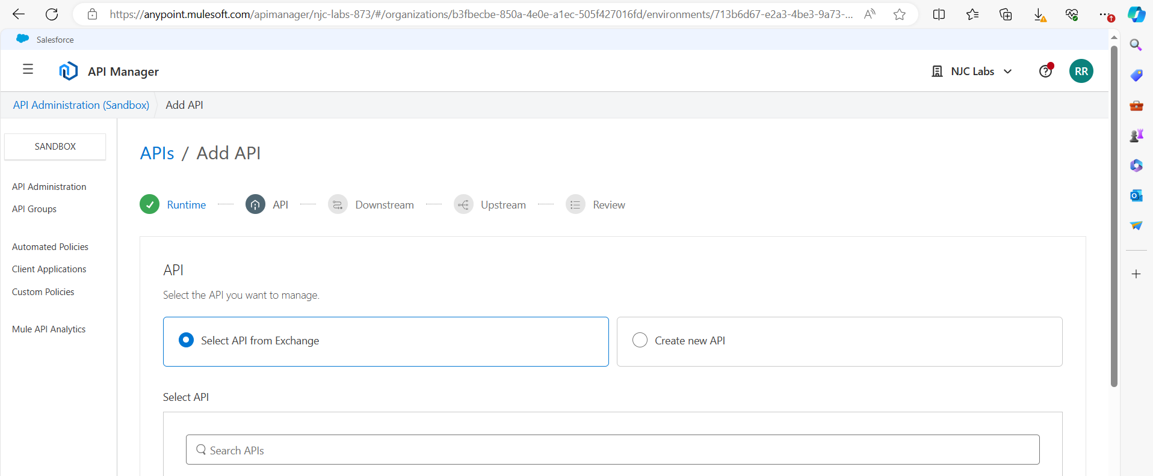

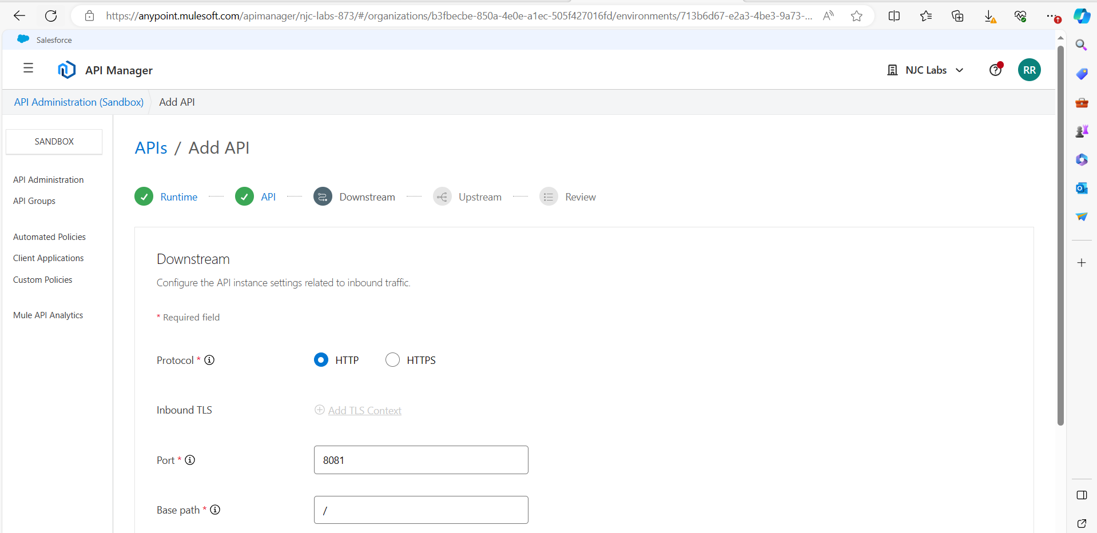

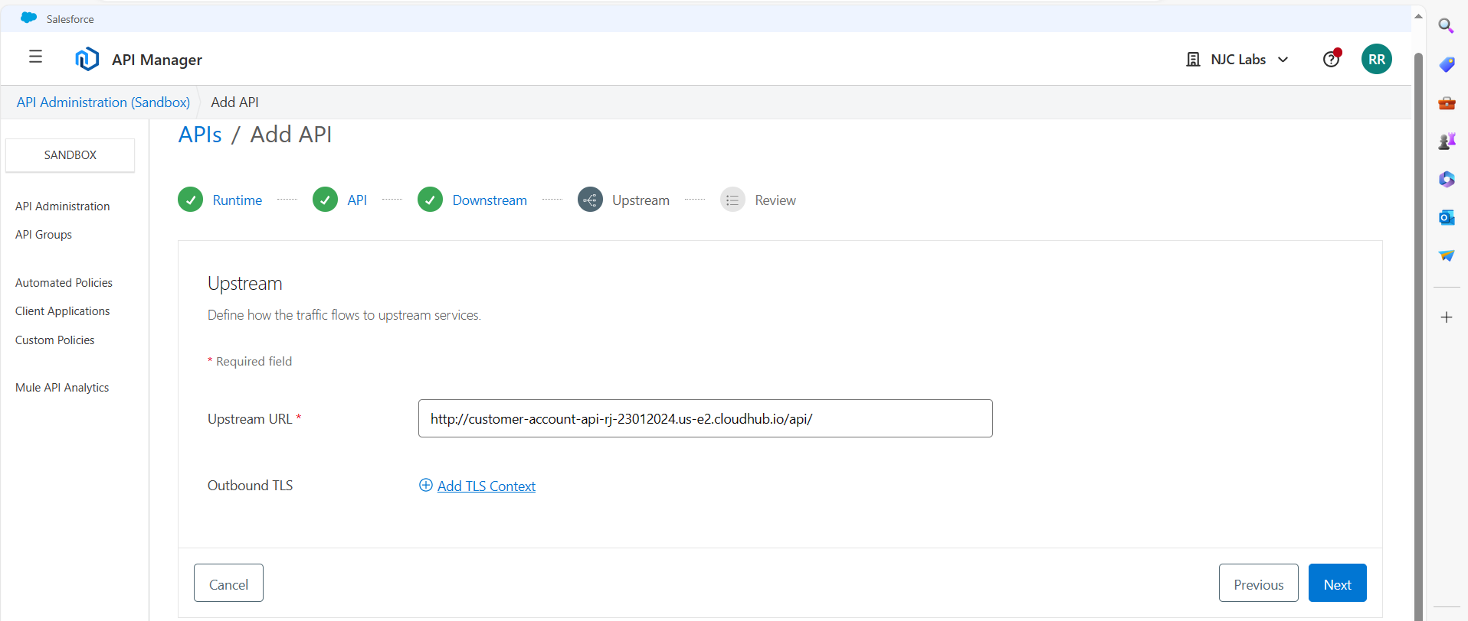

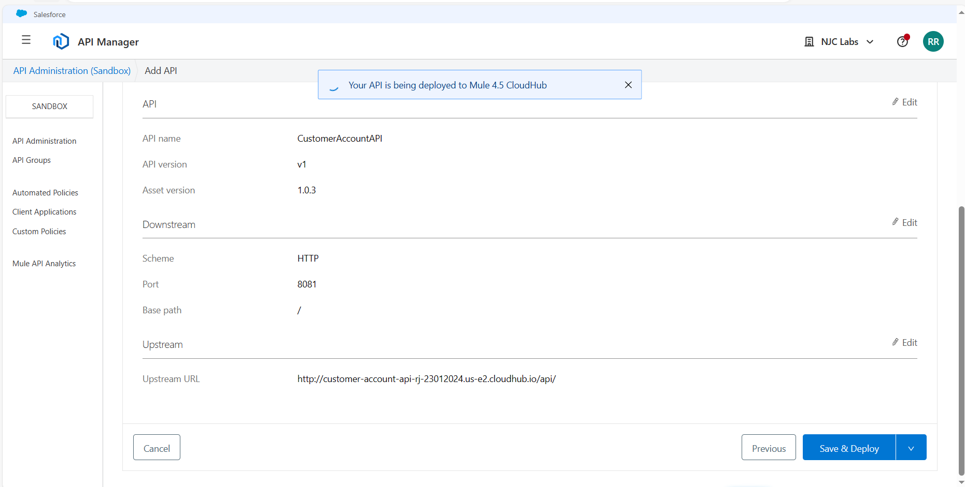

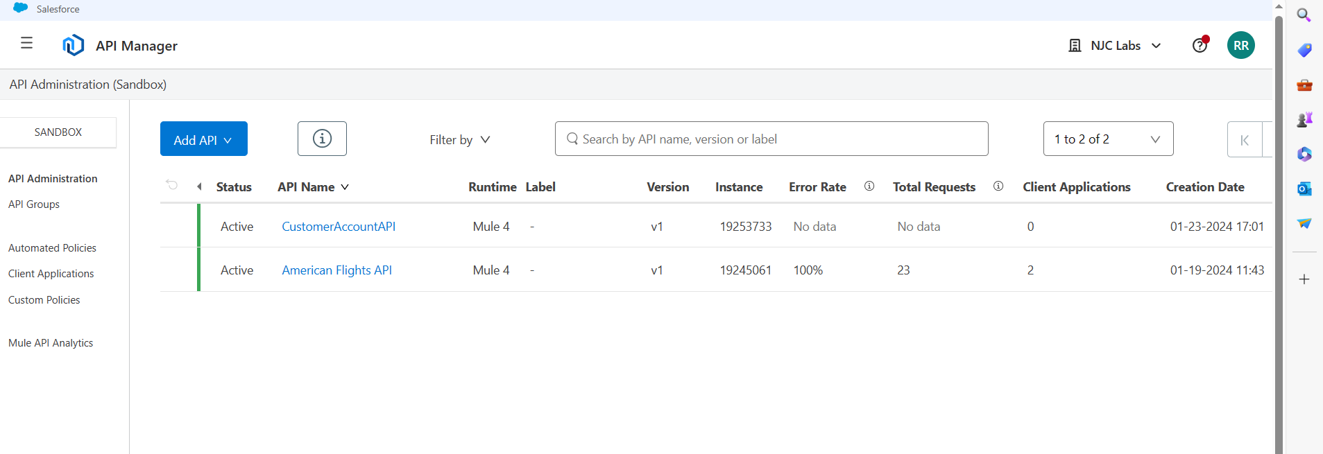

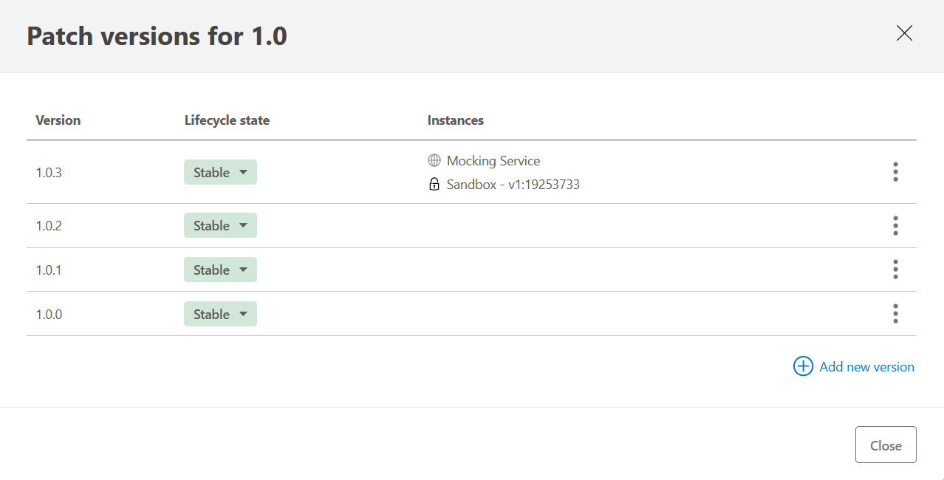

New Proxy does not have a URL:

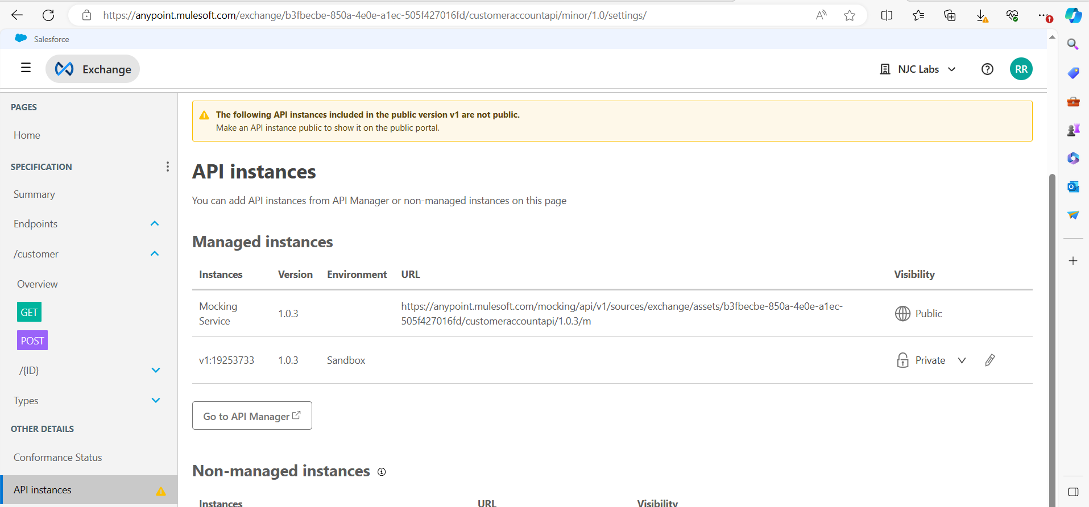

Set a consumer endpoint for the proxy in API Manager

From API Manager: Copy the Proxy url and got to Settings

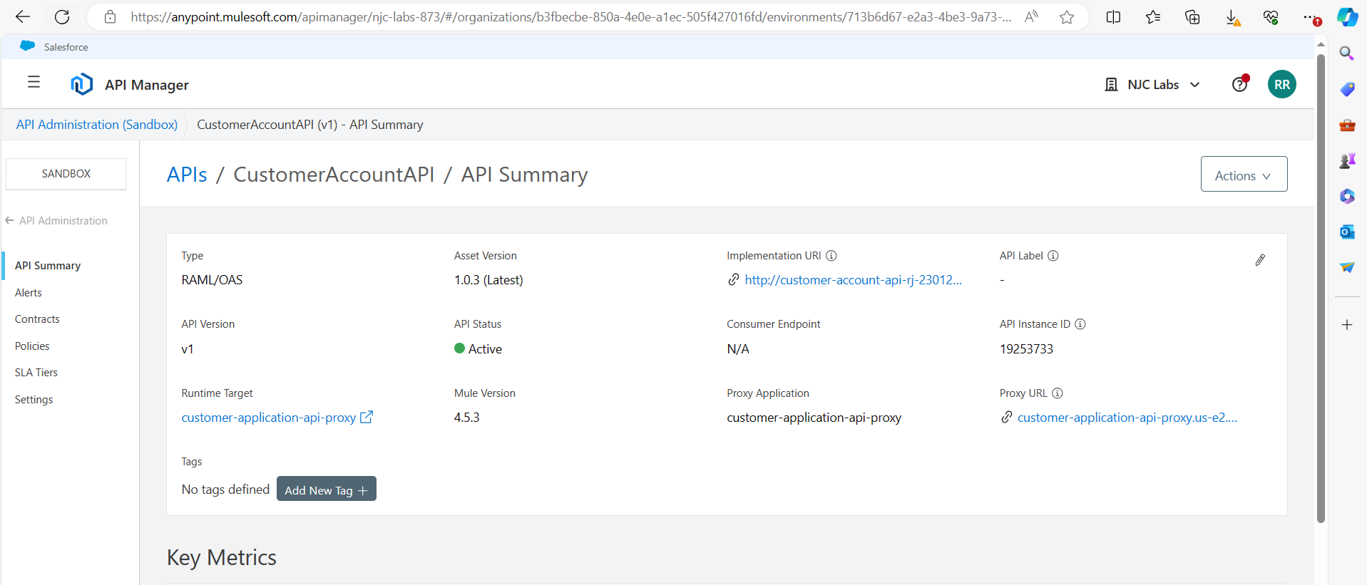

<http://customer-application-api-proxy.us-e2.cloudhub.io/>

Copy it in Consumer end point, also set the label to No policy

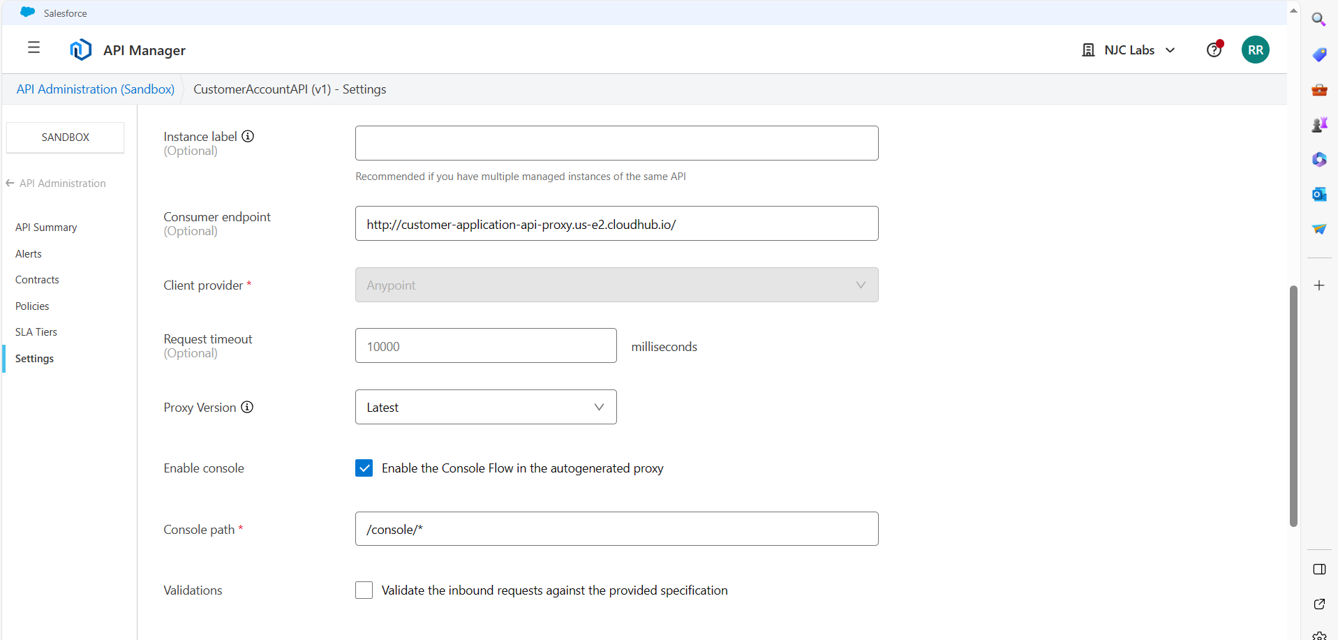

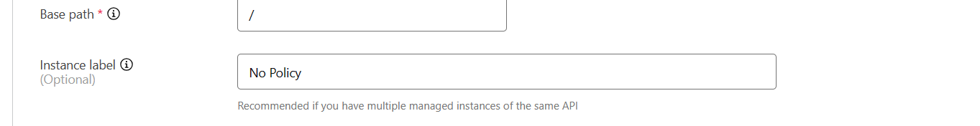

Make requests to the API proxy from Exchange

Go to the Exchange tab and refresh API instances:

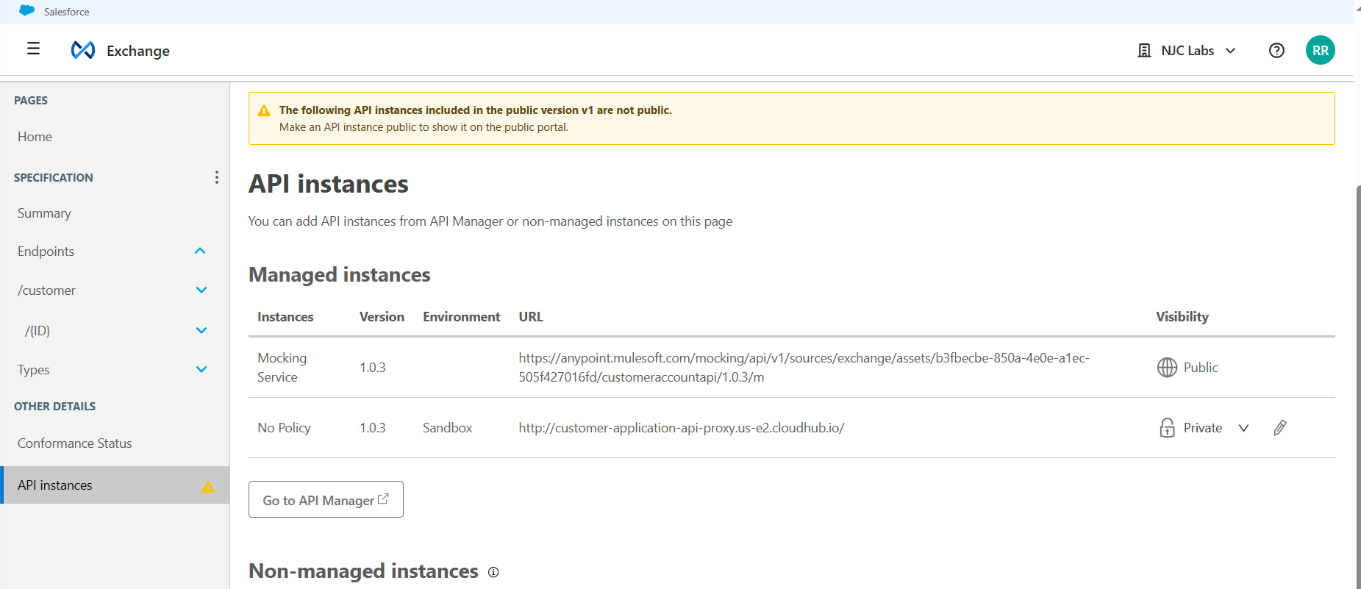

We can see the mocking service in the left side

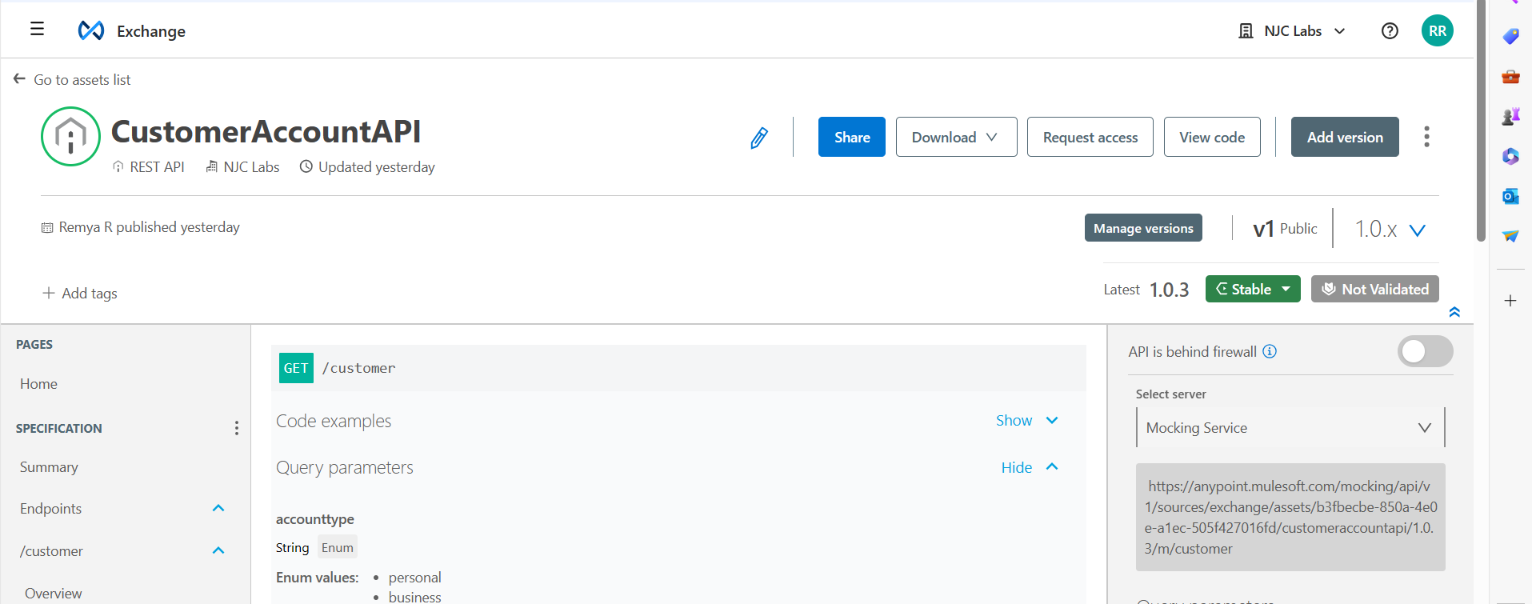

Select Sandbox-No Plicy and hit send button

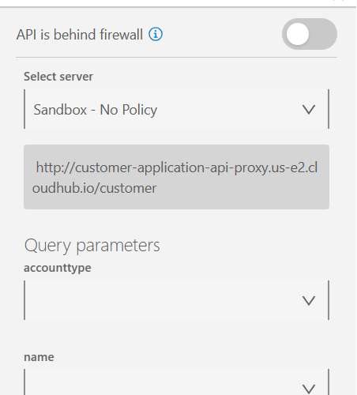

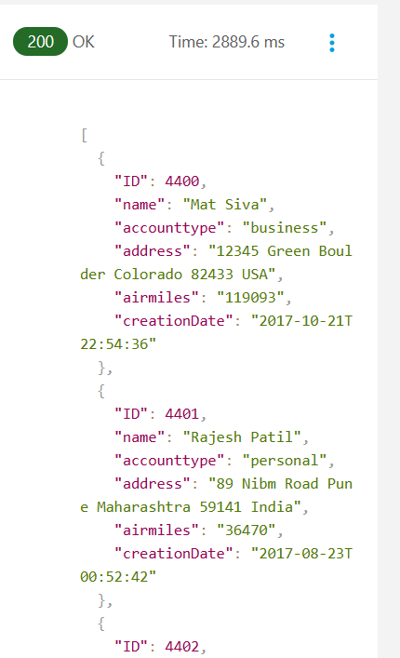

Then make instance to Public

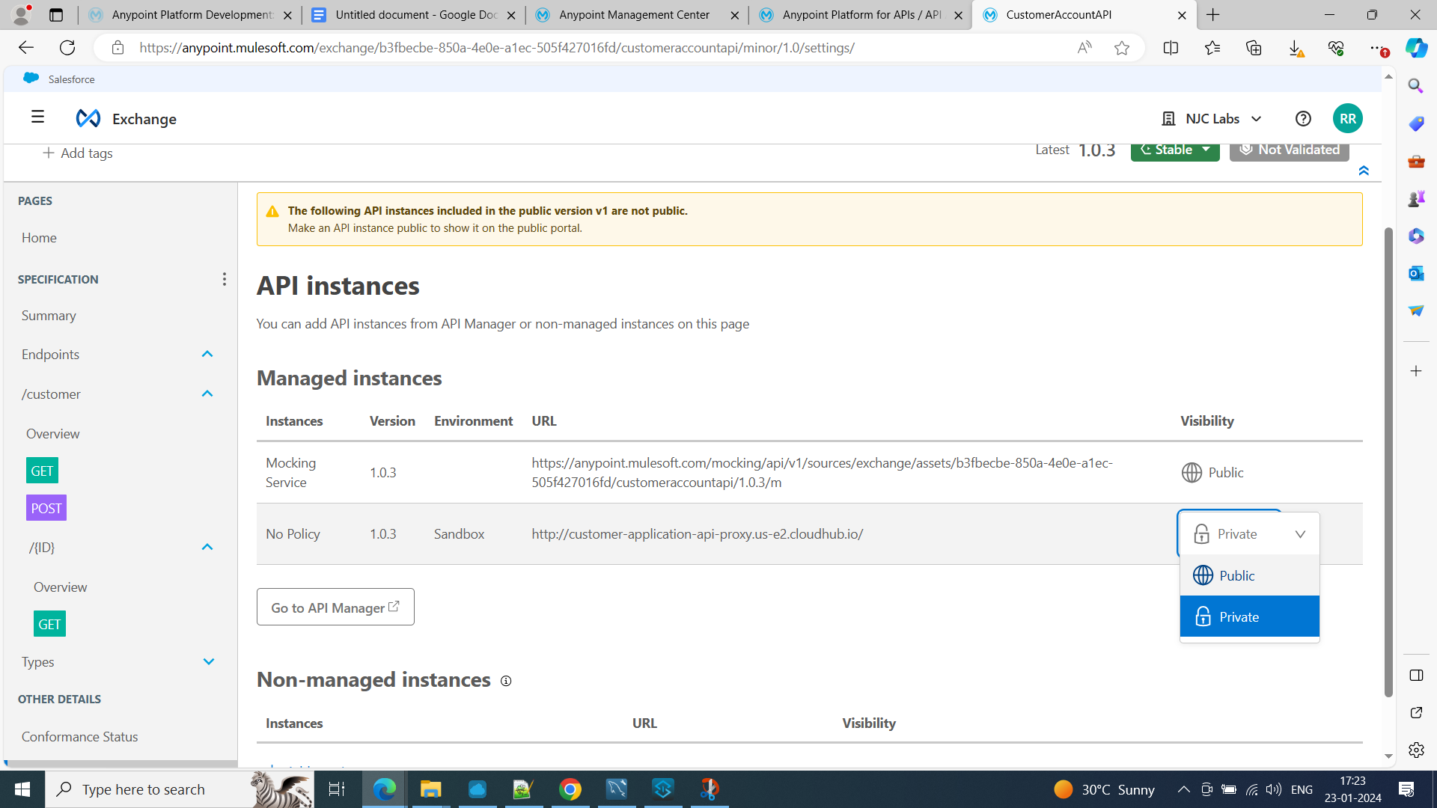

Test in ARC

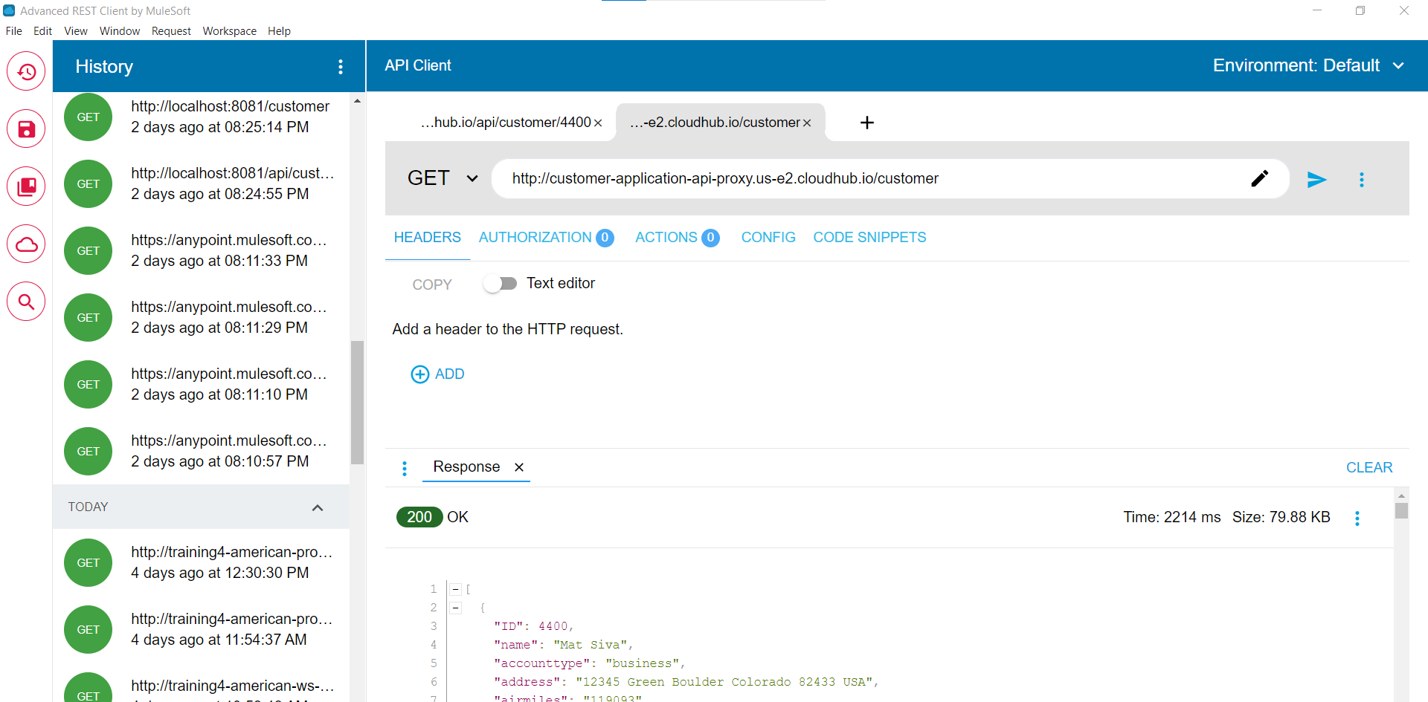

**Restricting access to API’s**

Create a rate limiting Policy

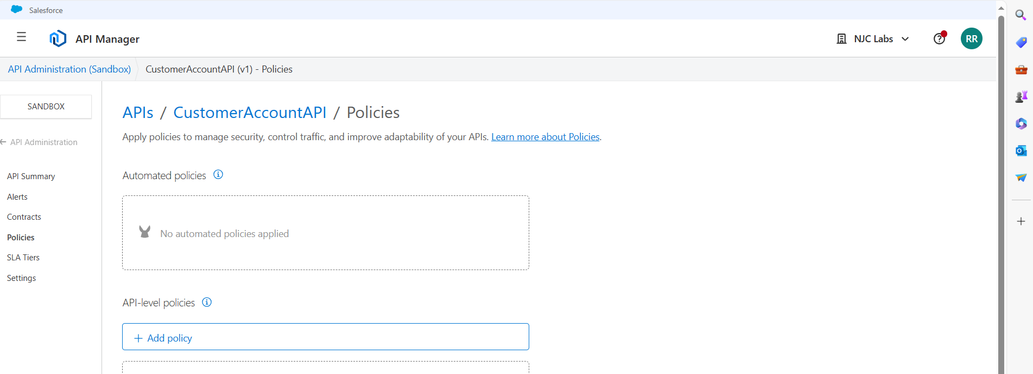

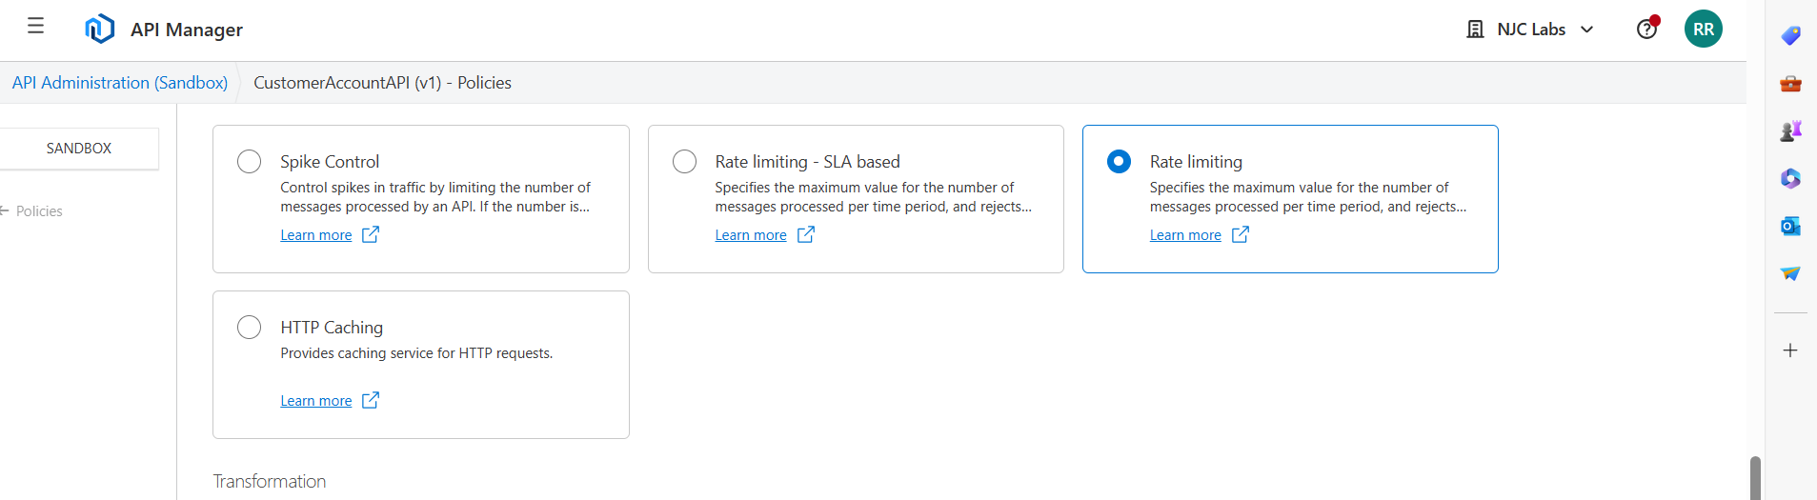

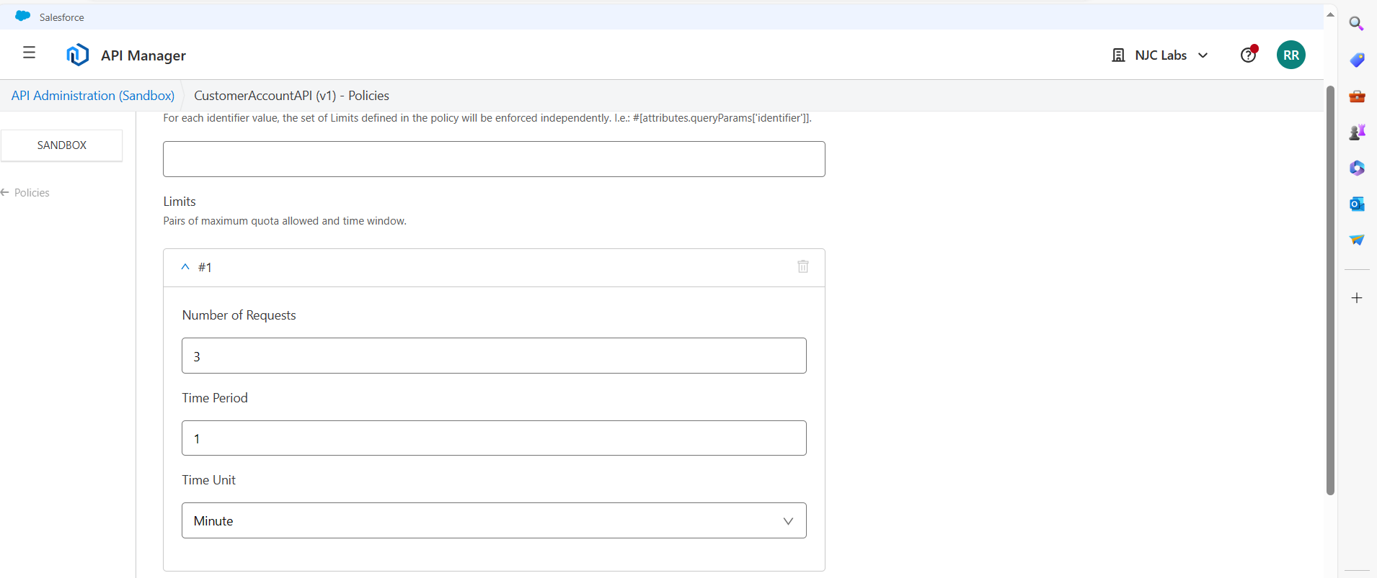

Select Expose Headers

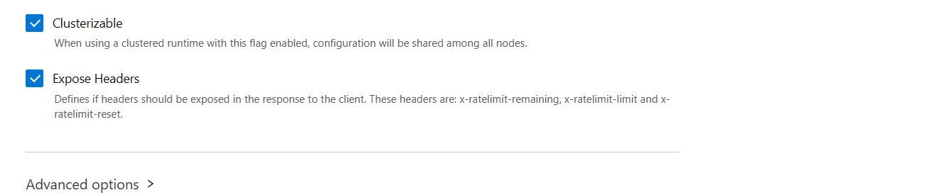

In the Settings, change instance label to Rate Limited Policy

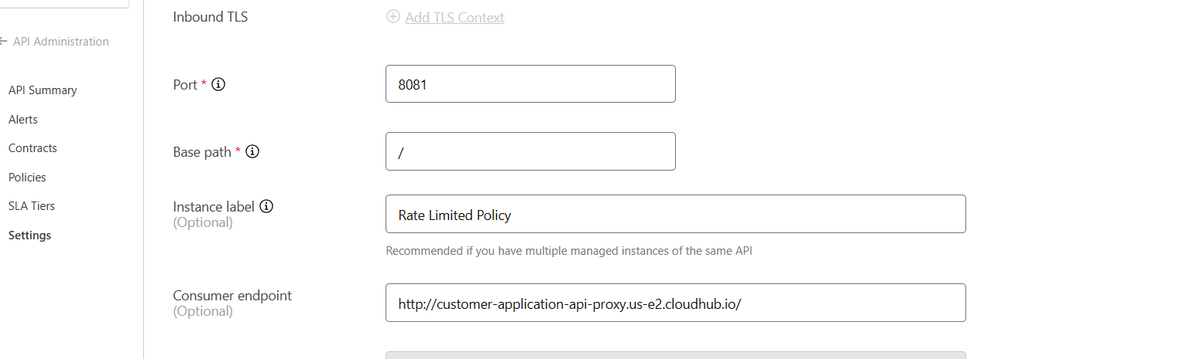

Test in ARC:

Check Headers:

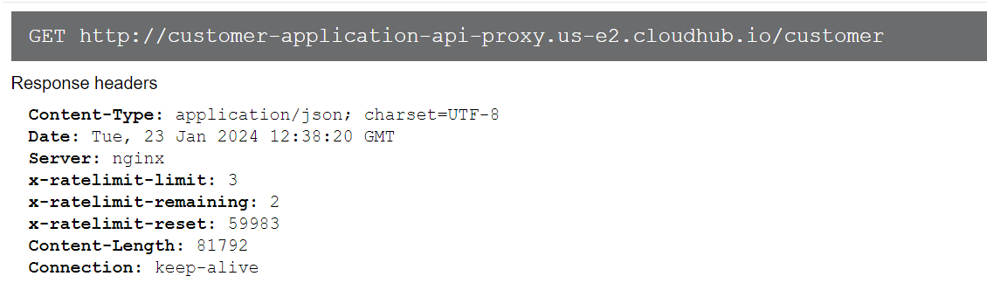

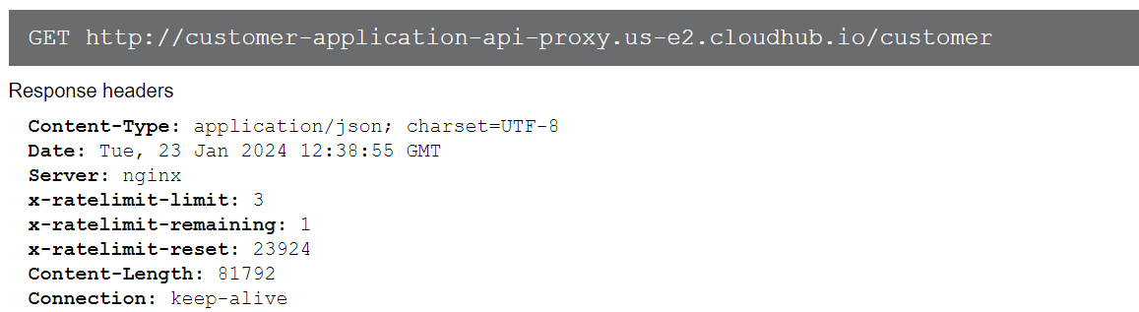

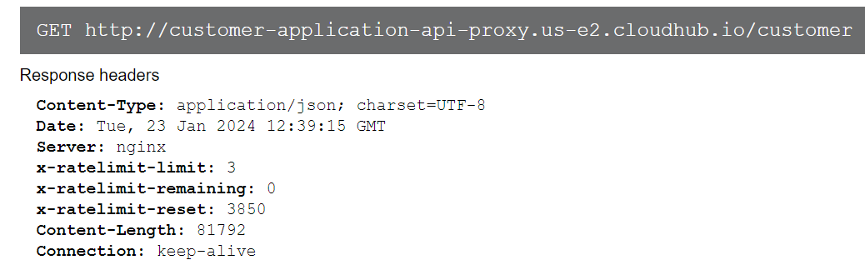

After 3 hit in 1 min :

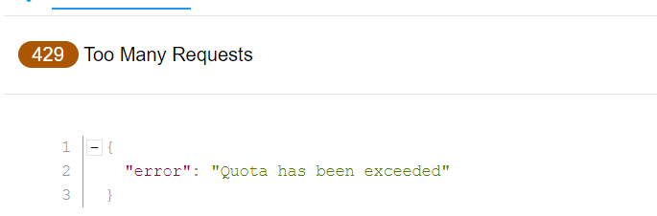

**Create SLA Tiers:**

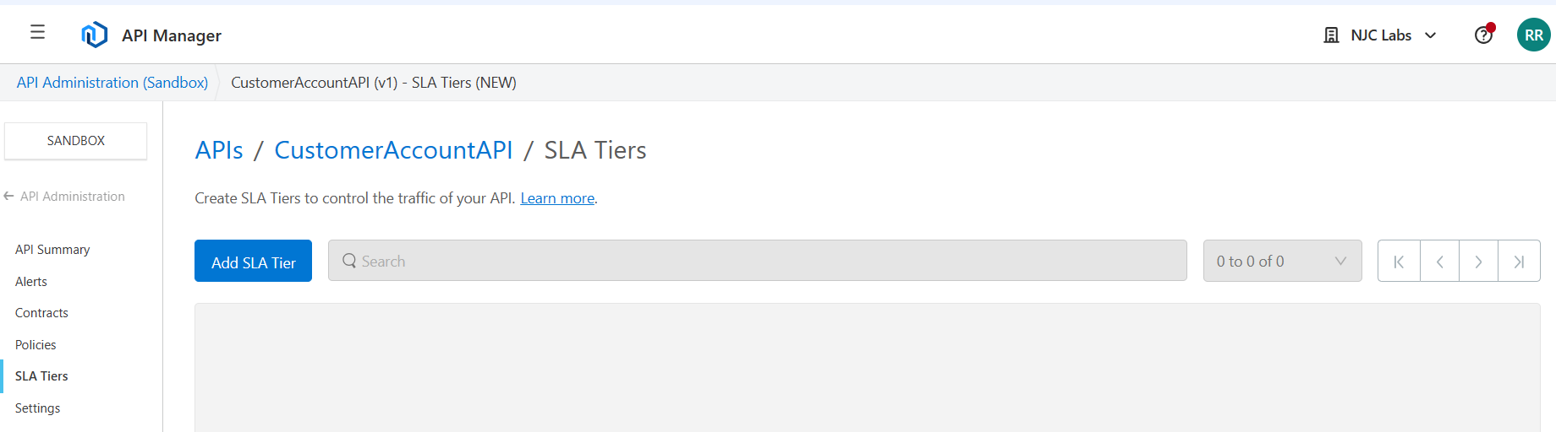

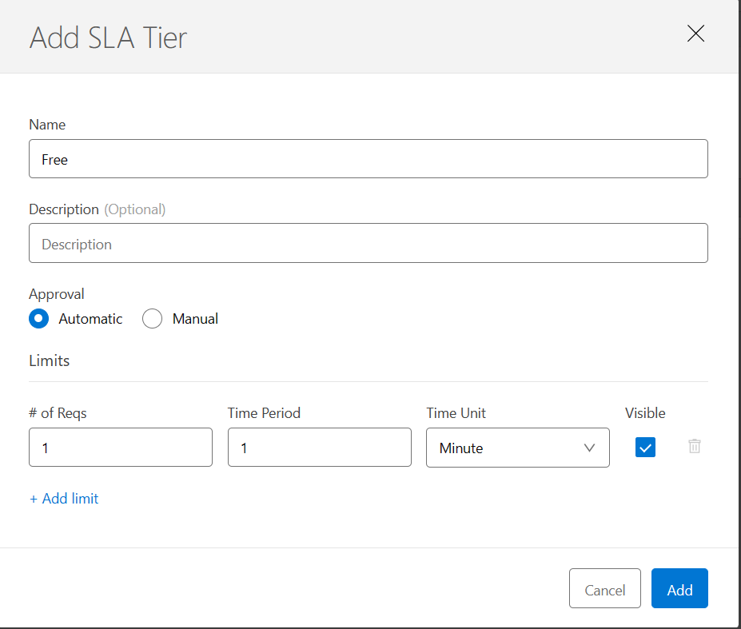

Create a second SLA tier with Manual Approval

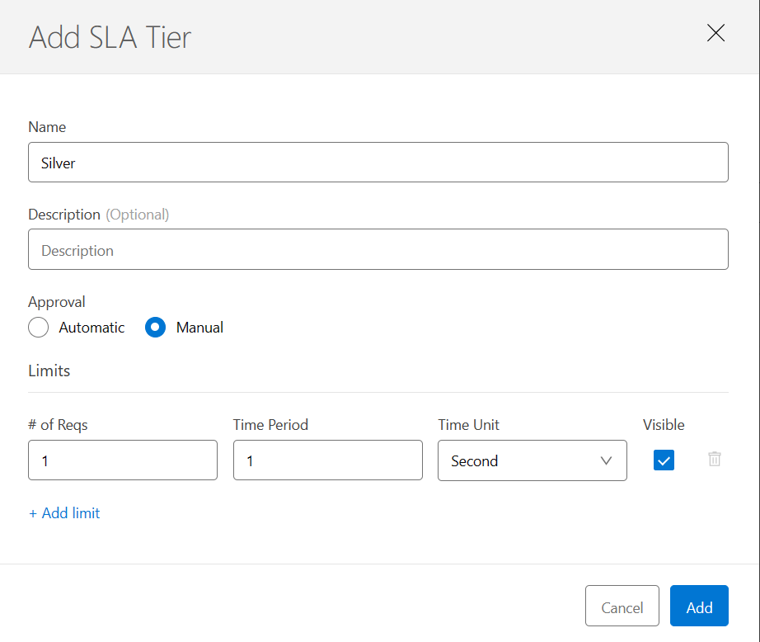

In the Policies, Remove Rate Limiting Policy , and add Rate Limiting Policy

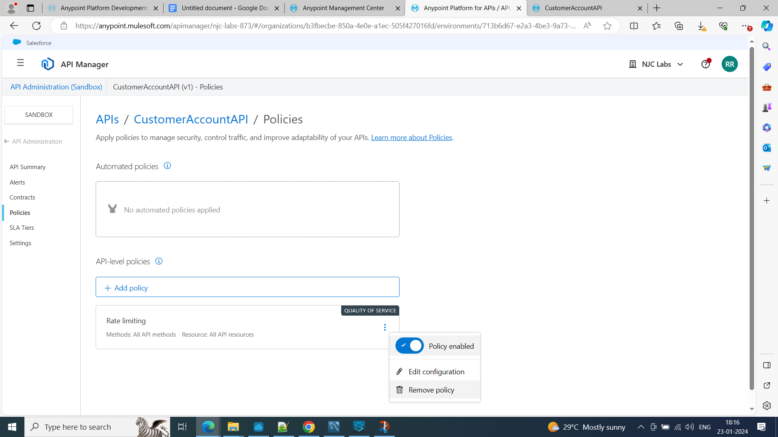

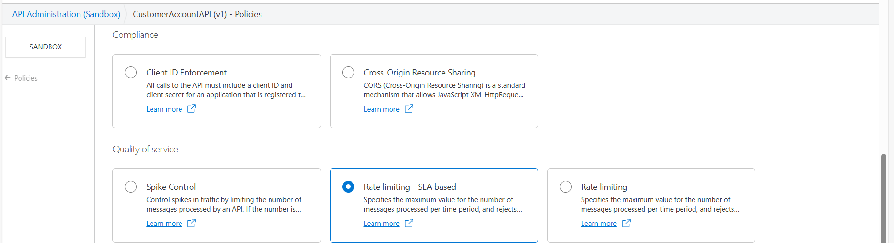

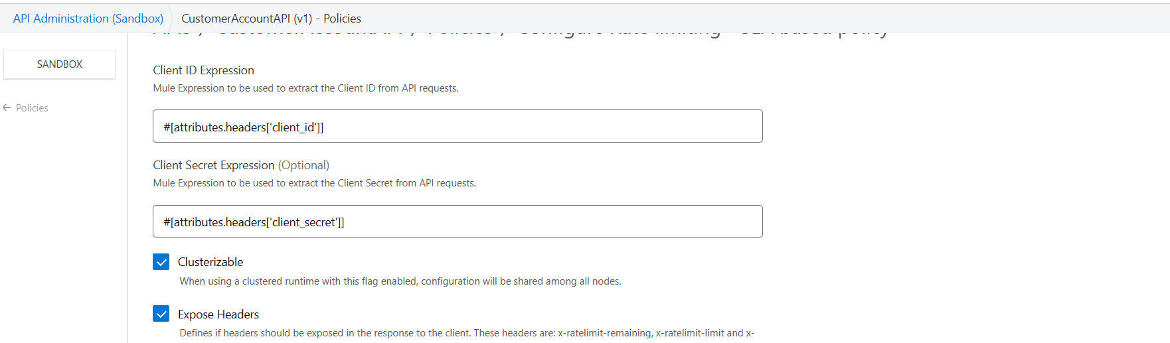

Test in ARC, we will get Invalid Client Id and Secret Id

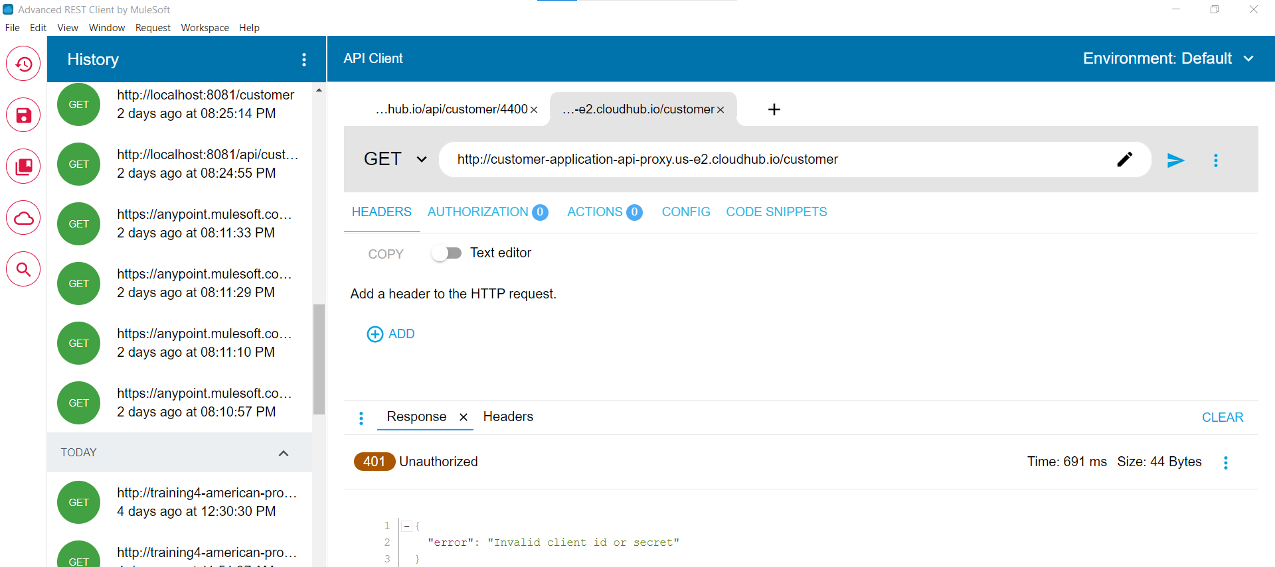

**Granting access to API’s**

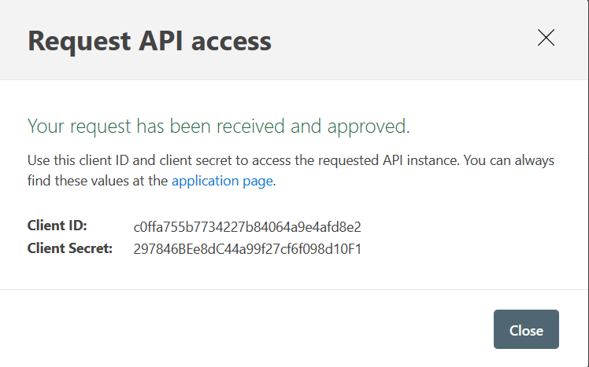

Client ID: c0ffa755b7734227b84064a9e4afd8e2

Client Secret: 297846BEe8dC44a99f27cf6f098d10F1

**Request access to the API as an external consumer**

In the public portal:

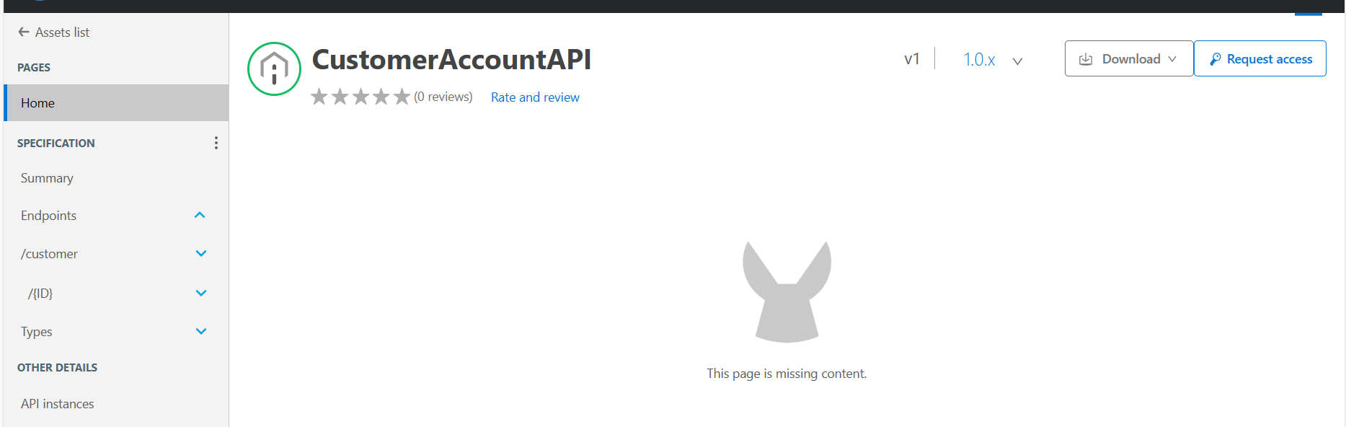

Request access:

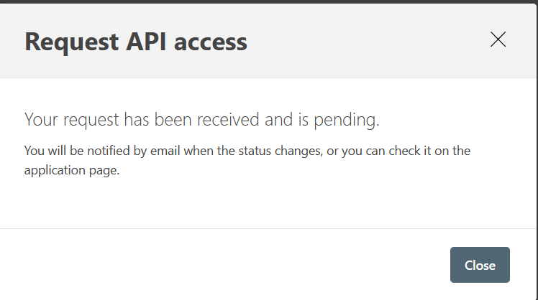

In the exchange - Contracts:

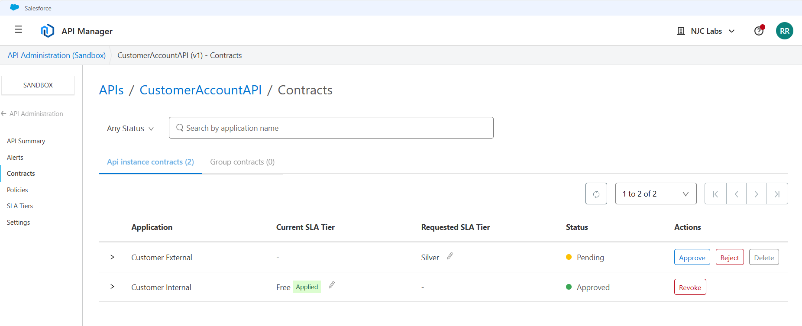

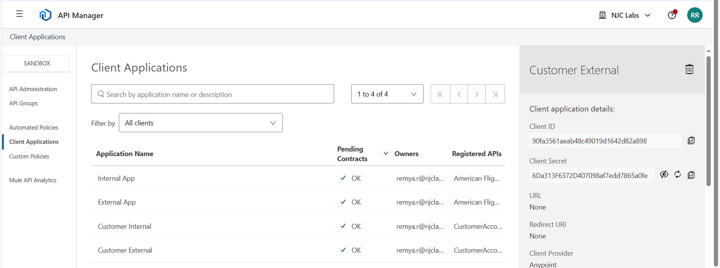

Client Id: 90fa3561aeab48c49019d1642d82a898

Client Secret: 6Da313F6372D407098af7edd7865a0fe

Test in ARC

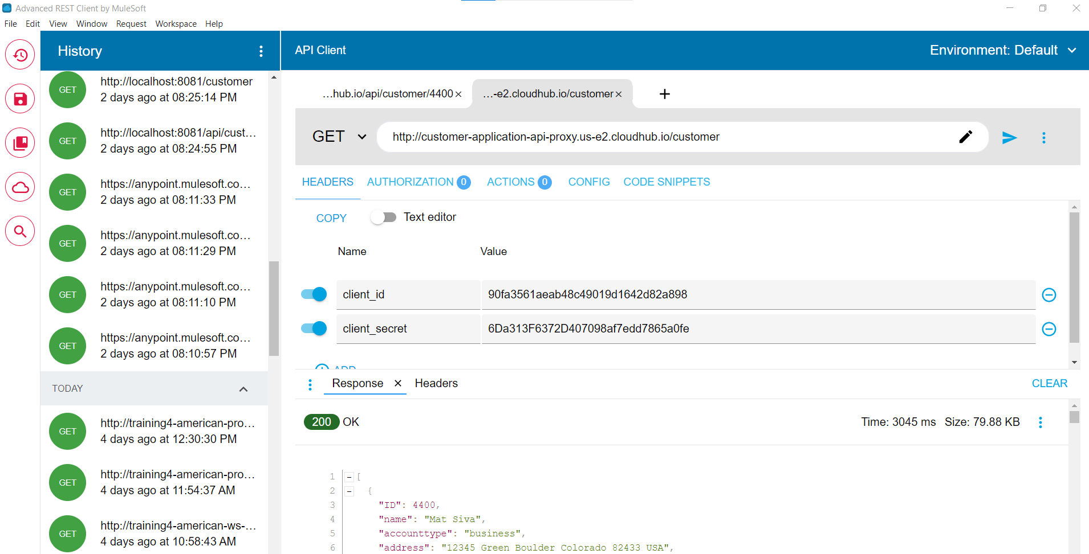

**Add Client ID enforcement to an API Specification**

API Manager -> Policies->API Specification snippet

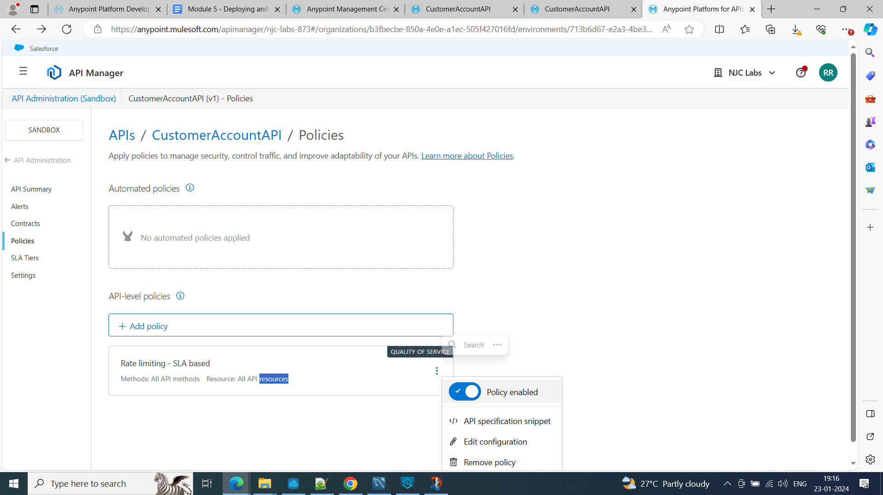

Copy traits and paste in RAML specification:

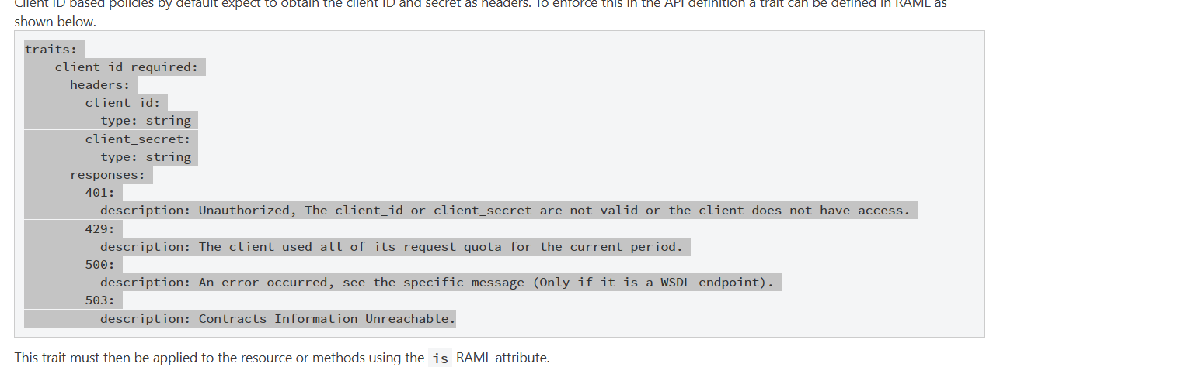

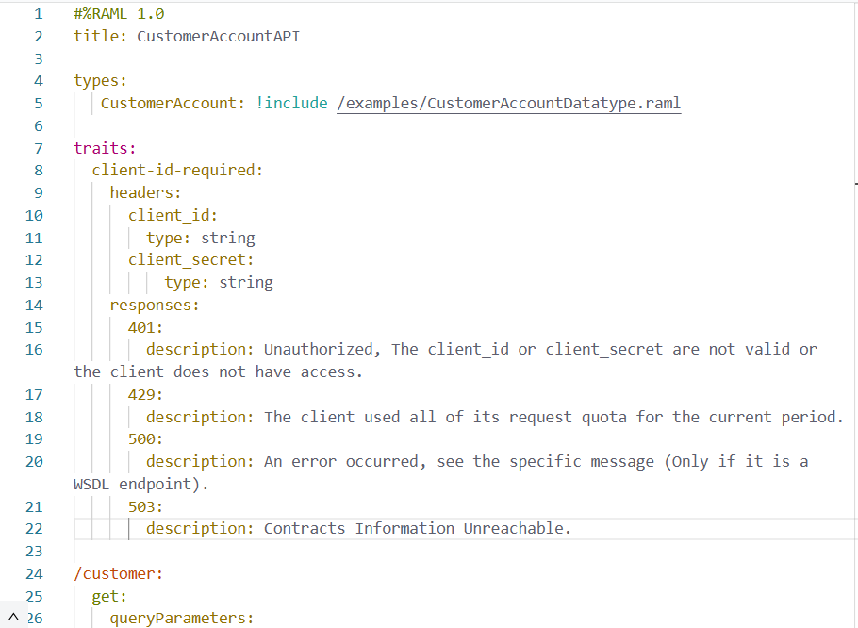

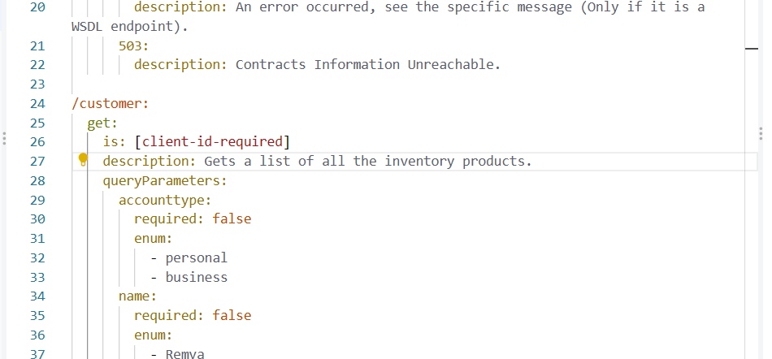

In the console:

